DAILY ONLINE ACTIVITIES SUMMARY

Date: |  | 22-05-2020 |  |  |  |  | Name: | Suhas prasad shetty
Sem & Sec |  | ₈th _{B} |  |  |  |  | USN: | 4AL16CS080
 |  |  |  |  | Online Test Summary
Subject |  |  | BDA
Max. Marks |  |  | 40 |  |  | Score |  | 20
 |  |  |  | Certification Course Summary
Course |  | AWS ARCITECTURE
Certificate Provider |  |  |  | AWS |  | Duration |  |  | 30 minutes
 |  |  |  |  | Coding Challenges

Problem Statement: Find the number that is missing from the array containing n distinct number taken from 0,1,2....n

Status: completed

Uploaded the report in Github | yes
If yes Repository name | Online certification course
Uploaded the report in slack | yes

Online Test Details:
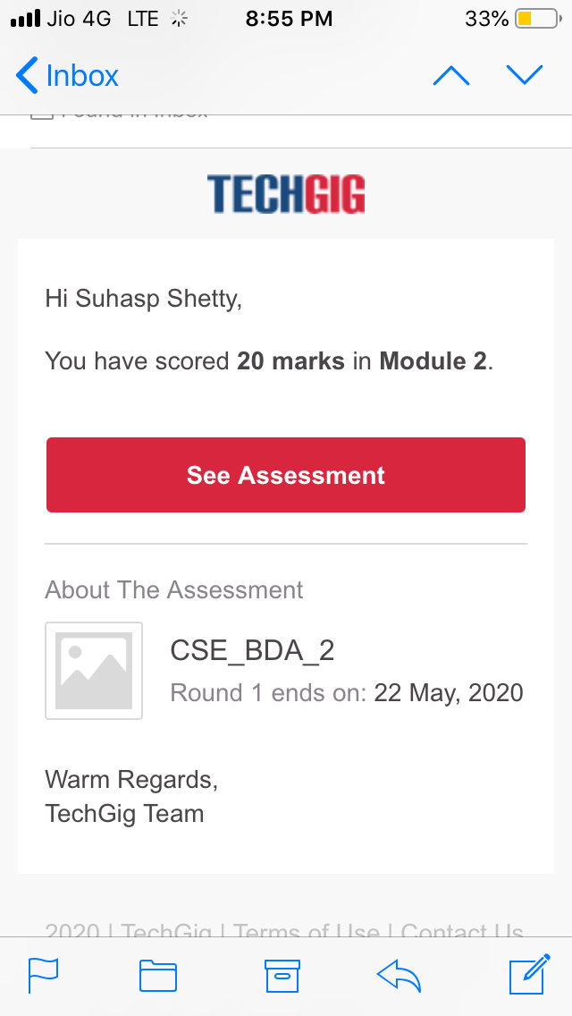

Certification Course Details
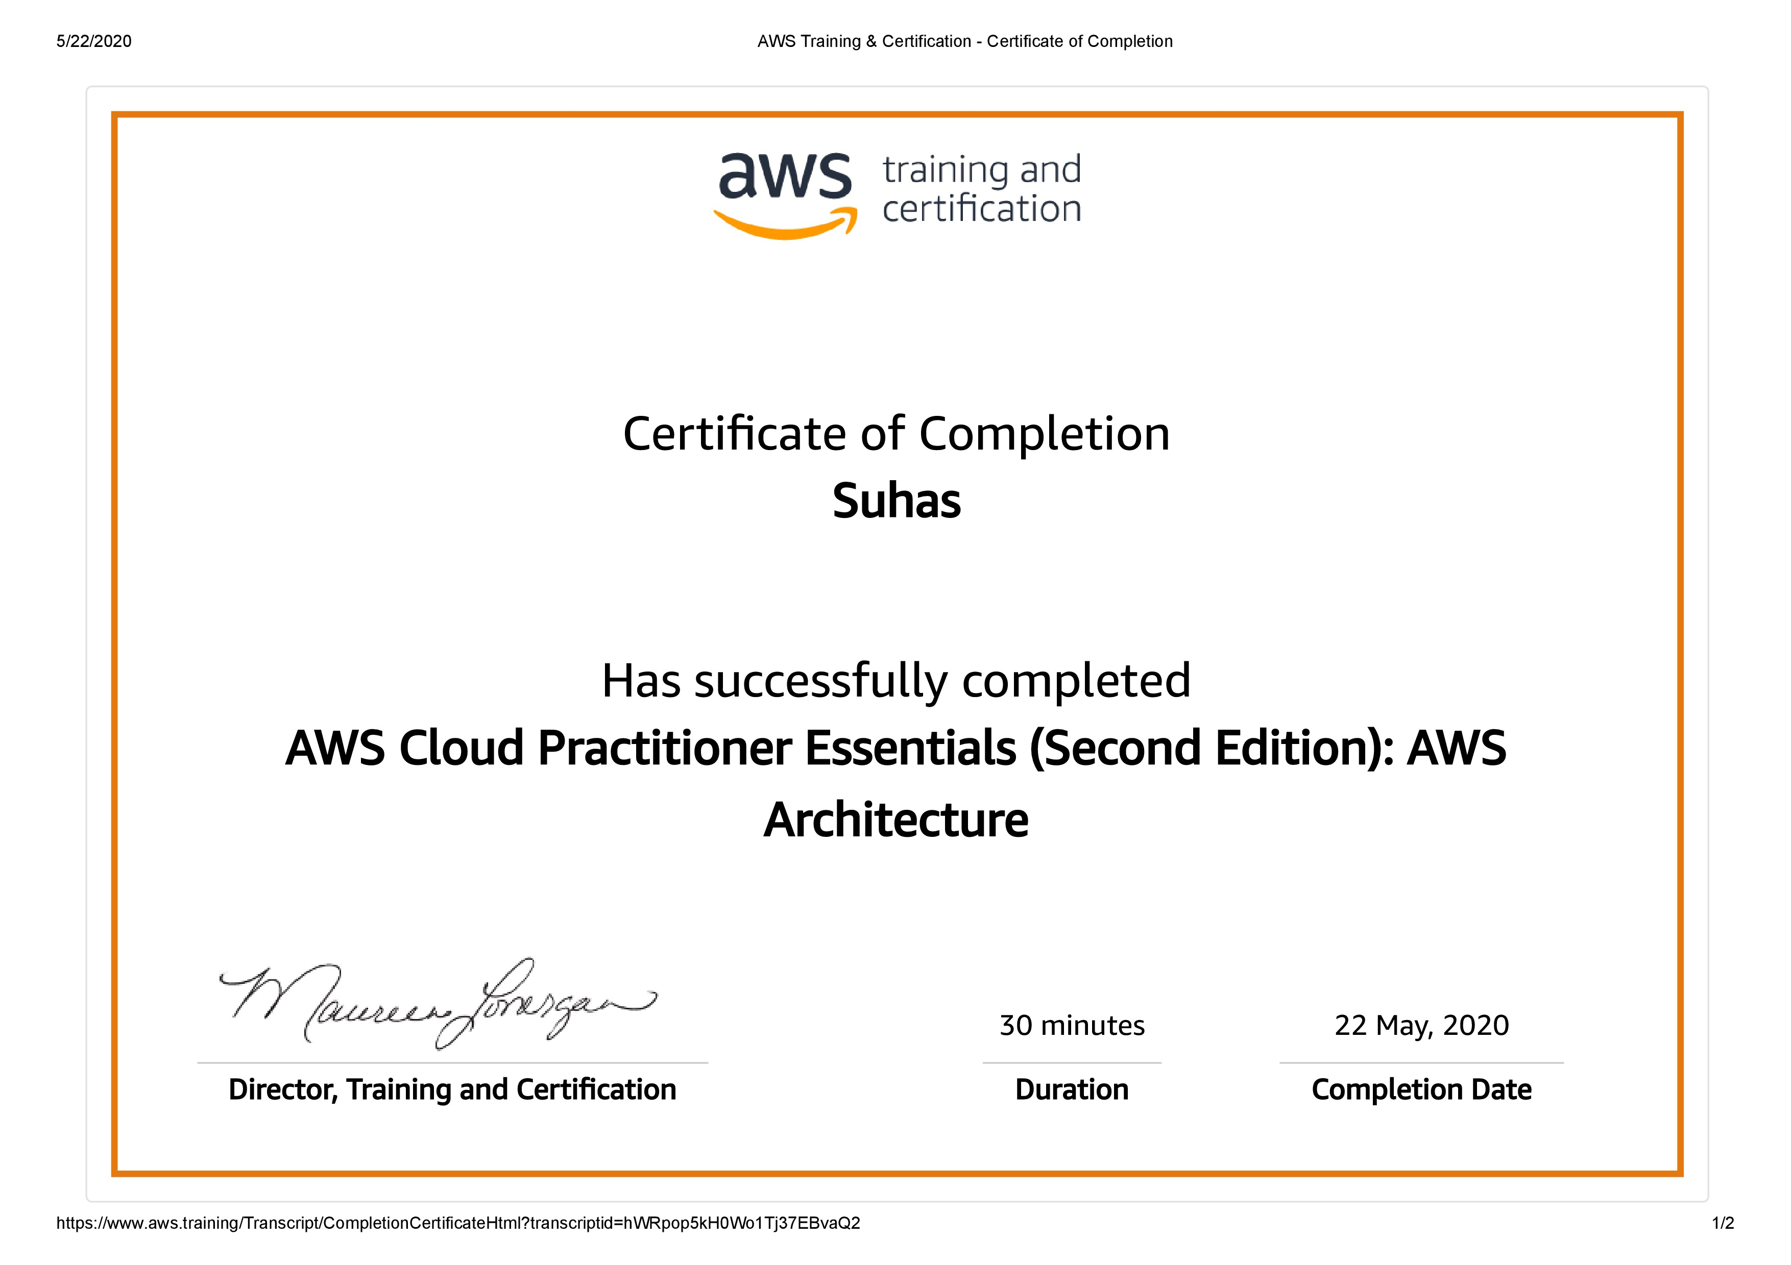

Coding Challenges Details

PROGRAM1

#include stdio.h

int getMissingNo(int a[], int n)

{

int i, total;

total = (n + 1) * (n + 2) / 2;

for (i = 0; i < n; i++)

total -= a[i];

return total;

}

int main()

{

int a[] = { 1, 2, 4, 5, 6 };

int miss = getMissingNo(a, 5);

printf("%d", miss);

getchar();

}

